Тест по английскому языку 3 класс. Тема «Животные»
1. Odd one out
A) a cat C)a tiger
B)a monkey D) a chair
2. … live in water.
A) zebras C) crocodiles
B) lions D) kangaroos
3. … likes milk.
A) a kitten C) a hamster
B) a fish D) a mouse
4. What’s this?
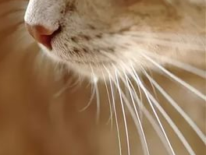
A) eyes C) whiskers
B) ears D) arms
5. It is a wild animal. It is black or brown. It is funny. It talkes with its face and hands.
A) a tiger C) a kangaroo
B) a monkey D) a lion
6. What animal is it?
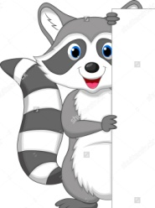
A) a raccoon C) a hamster
B) a parrot D) a guinea pig
7. … can’t fly.
A) parrots C) pelicans
B) penguins D) birds
8. Odd one out
A) lizard C) mice
B) frog D) rabbit
9. What do bears do in winter?
A) play C) watch TV
B) eat D) sleep
10. Choose the correct sentence.
A) Dolphins have got legs, but they haven’t got tails.
B) Legs haven’t got dolphins, but tails they have got.
C) Dolphins have got tails, but they haven’t got legs.
D) Legs have got dolphins, but tails they haven’t got.
11. Lions … four legs.
A) have got C) are
B) like D) has got
12. It lives in the river. It is green. What is it?
A) a bear C) a tiger
B) a kangaroo D) a crocodile
13. Domestic animals are cats, dogs, hamsters, pigs, horses, …
A) wolves C) cows
B) foxes D) hares
14. … is a man’s best friend
A) A frog C) A cat
B) A lion D) A dog
15. It likes bones. It is dog’s baby. What is it?
A) a hamster C) a mouse
B) a puppy D) a kitten

Ключи
1 D
2 C
3 A
4 C
5 B
6 A
7 B
8 C
9 D
10 C
11 A
12 D
13 C
14 D
15 B

